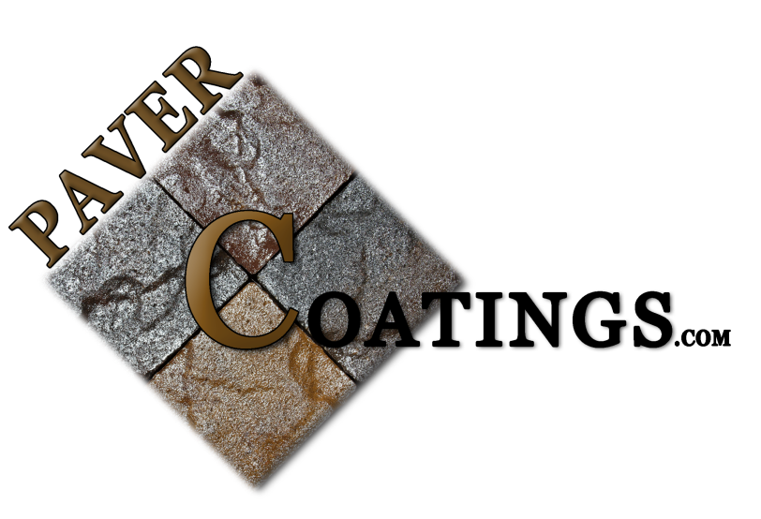

Paver Coatings
11803 N Saguaro Blvd. Ste.14 | Fountain Hills, AZ 85268
480-271-7630
PCAC-25
PRODUCT DESCRIPTION AND USE

PCAC-25 is a clear, solvent-based acrylic designed for sealing conventional concrete,
exposed aggregate, porous tile, concrete pavers, and a variety of architectural concrete surfaces.
PCAC-25 is based on a hard acrylic polymer that produces coatings that give excellent gloss, stain resistance, and clean ability. Adhesion to properly prepared cementitious surfaces is excellent
and the material is completely non-yellowing. PCAC-25 is produced in a standard formulation that
meets Arizona VOC requirements and a second formulation that meets the 100 gram/liter
California standard. Both formulations bring out the rich, natural beauty of the substrate.

Chemical Composition

High molecular weight thermoplastic acrylic resin dissolved in a specially formulated blend of
solvents.

Limitations

• Do not use on exterior on-grade flagstone, sandstone or slate.
• Use in heavy foot traffic areas requires regular maintenance coating.
• Will not resist solvents or brake fluid.
• Concrete must be absolutely dry.

TECHNICAL DATA
Physical Properties

Solids Content, by Weight ............................................................................... 25%
Volatile Organic Compounds (Standard formula) ............................. 580 grams/liter
Volatile Organic Compounds (San Diego County and OTC States) 399 grams/liter
Volatile Organic Compounds (California formula) ............................ 100 grams/liter
Hardness ...............................................................................................................16
60º Gloss (4 mil dry film) ......................................................................................75
Adhesion to Concrete (ASTM 451) ..................... concrete fails before loss of bond
Dry Times (77º6 mil wet film)
Recoat .................................................................................. 30-60 minutes
Light Traffic ..................................................................................... 4 hours
Full Cure ....................................................................................... 72 hours
Higher temperatures will shorten dry times and lower temperatures will lengthen dry times.
Thicker films will take longer to dry.

WARRANTY INFORMATION

Pavercoatings.com guarantees that this product is free from manufacturing defects and complies with our published specifications. In the event that the buyer proves that the goods received do not conform to these specifications or were defectively manufactured, the buyer’s remedies shall be limited to either the return of the goods and repayment of the purchase price or replacement of the defective material at the option of the seller.
PAVERCOATINGS.COM MAKES NO OTHER WARRANTY, EXPRESSED OR IMPLIED, AND ALL WARRANTIES OF MERCHANTABILITY AND FITNESS FOR A PARTICULAR PURPOSE ARE HEREBY DISCLAIMED. Pavercoatings.com shall not be liable for damages caused by application of its products over concrete with excessive moisture vapor transmission or alkalinity. Pavercoatings.com shall not be liable for any injury incurred in a slip and fall accident. Manufacturer or seller shall not be liable for prospective profits or consequential damages resulting from the use of this product. SPECIALIZED FLOOR COATINGS & DECORATIVE CONCRETE SYSTEMS.

GENERAL INFORMATION

- Moisture Vapor Emissions/Alkalinity Precautions:
All interior concrete floors not poured over an effective moisture vapor retarder are subject to
possible moisture vapor transmission and related high levels of alkalinity that may lead to
blistering and failure of the coating system. It is the coating applicator’s responsibility to conduct
calcium chloride and relative humidity probe testing to determine if excessive levels of vapor
emissions or alkalinity are present before applying any coatings. Paver Coatings can supply moisture remediation products. Consult with our technical department. Paver Coatings and its sales agents are not responsible for coating failure as a result of undetected moisture vapor emissions.

- Surface Preparation:
Surface must be clean, sound and absolutely dry. Surface preparation should be done with a
floor machine and nylogrit type brush. Scrub the surface well using Pavercoatings.com Cleaner Degreaser
1 with water. Do not let cleaning solution dry on the surface. Rinse well with water and allow to
dry thoroughly before coating.

- Application Recommendations:
PCAC-25 may be applied by brush, roller, airless sprayer or floor squeegee. If rolling the
material, use a 1/2-3/4 inch nap roller cover and work from a roller pan or 5 gallon pail. Use the
dip and roll method. Do not pour the material on the surface. Because the material dries quickly,
apply liberal amounts, work small areas and keep a wet edge. Distribute the material evenly by
slightly overlapping the area previously coated. Roll laterally across the body and roll again with
a vertical up and down motion. Application rates will vary from 200-400 sq. ft. per gallon
depending upon the texture and porosity of the substrate. PCAC-25 may be thinned with MEK,
Xylene or Acetone if desired. If using in California, use only Acetone to maintain VOC
compliance.

- Recoating:
PCAC-25 may be recoated with itself as soon as it is tack free, usually 20-40 minutes. Recoating with itself after the material is fully cured requires that the surface be clean and dry. No abrading is necessary. Recoating with other materials can be problematic and requires thorough cleaning and abrading. Apply to a small test area and conduct a tape pull test prior to the main application. Contact factory for specific test instructions.

- Handling Precautions:
Material is flammable. Extinguish all flames, pilot lights and electric motors until all vapors are
gone and the coating is hard. The vapor is harmful. Do not use indoors unless area can be
properly ventilated. Use a cartridge type respirator during application. Avoid contact with skin,
wear protective gloves. Read Material Safety Data Sheet before using.
- Slip and Fall Precautions:
OSHA and the American Disabilities Act (ADA) have now set enforceable standards for slip resistance on pedestrian surfaces. The current coefficient of friction required by ADA is .6 on level surfaces and .8 on ramps. Pavercoatings.com recommends the use of angular slip resistant aggregate in all coatings or flooring systems that may be exposed to wet, oily or greasy conditions. It is the contractor and end users’ responsibility to provide a flooring system that meets current safety standards. Pavercoating.com or its sales agents will not be responsible for injury incurred in a slip and fall accident.

